TASK 1

VISUALISATION USING FIXED LOD EXPRESSION

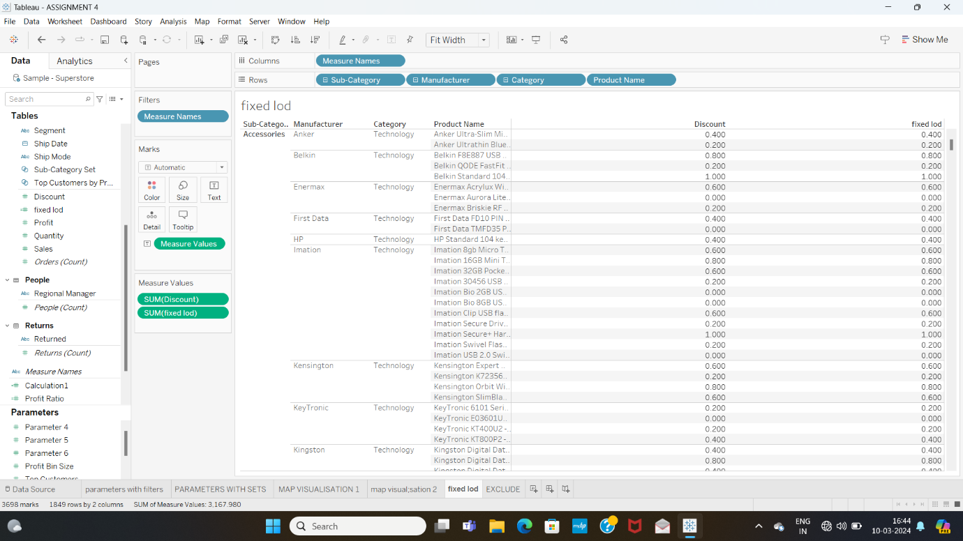

VISUALISATION USING EXCLUDE LOD EXPRESSION

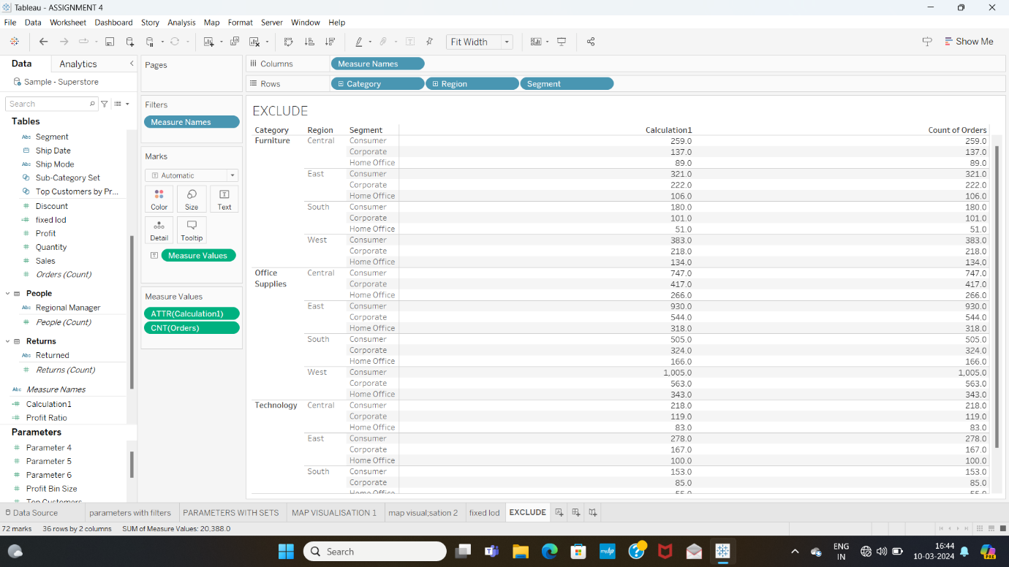

TASK 2 : MAP VISUALISATIONS USING GEOGRAPHICAL DATA

MAP 1

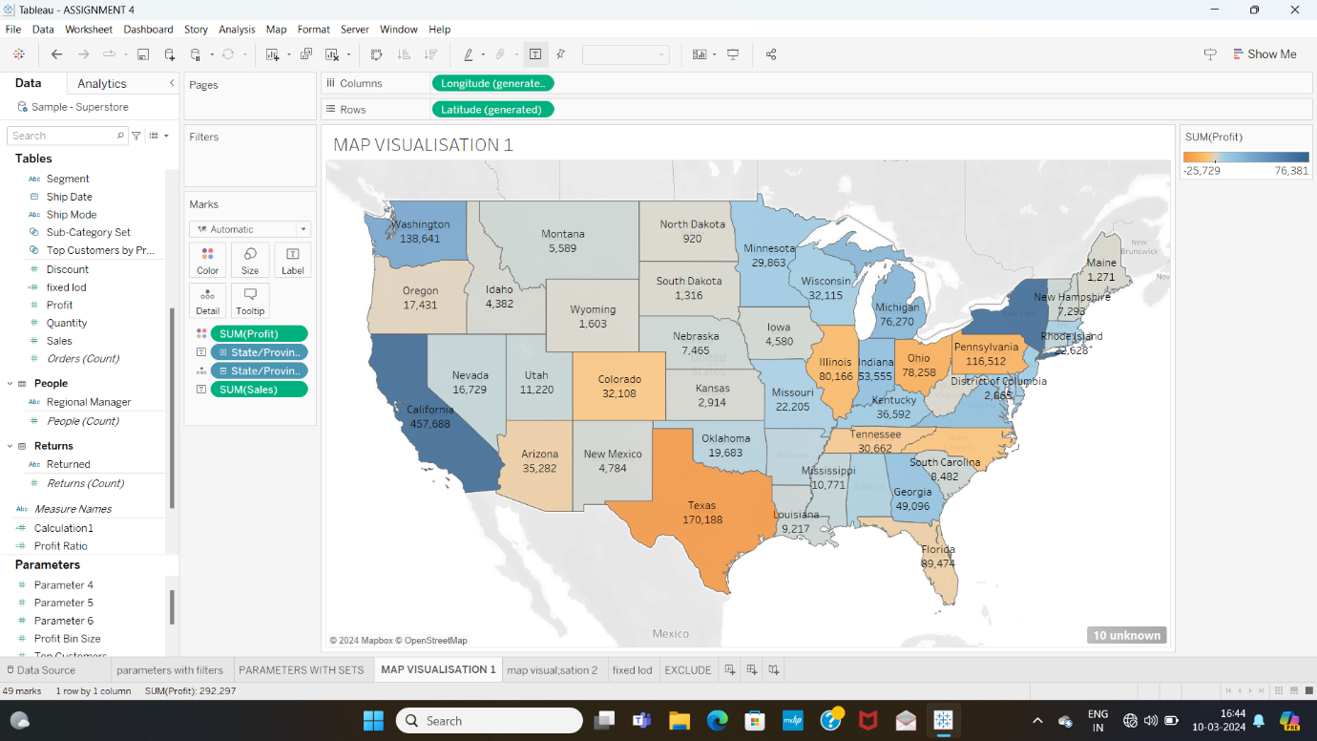

MAP 2

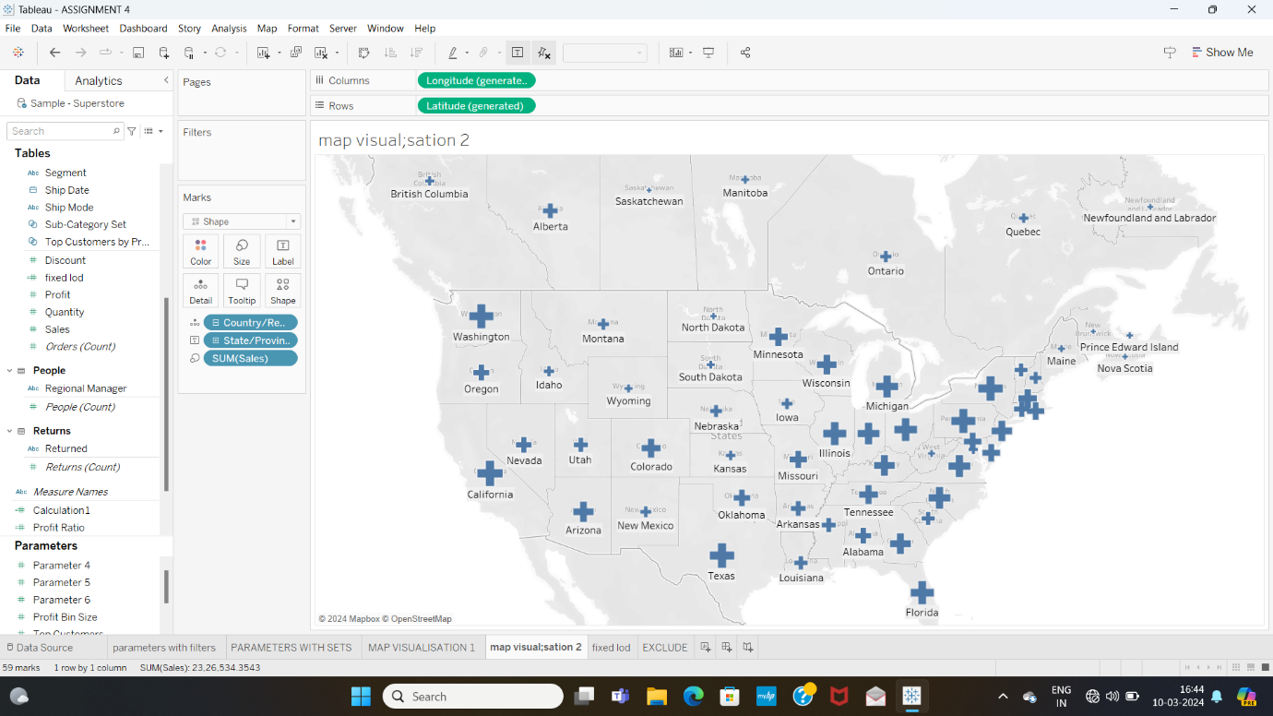

TASK 3: VISUALISATIONS USING DYNAMIC DIMENSION PARAMETERS

USING PARAMETER WITH FILTER

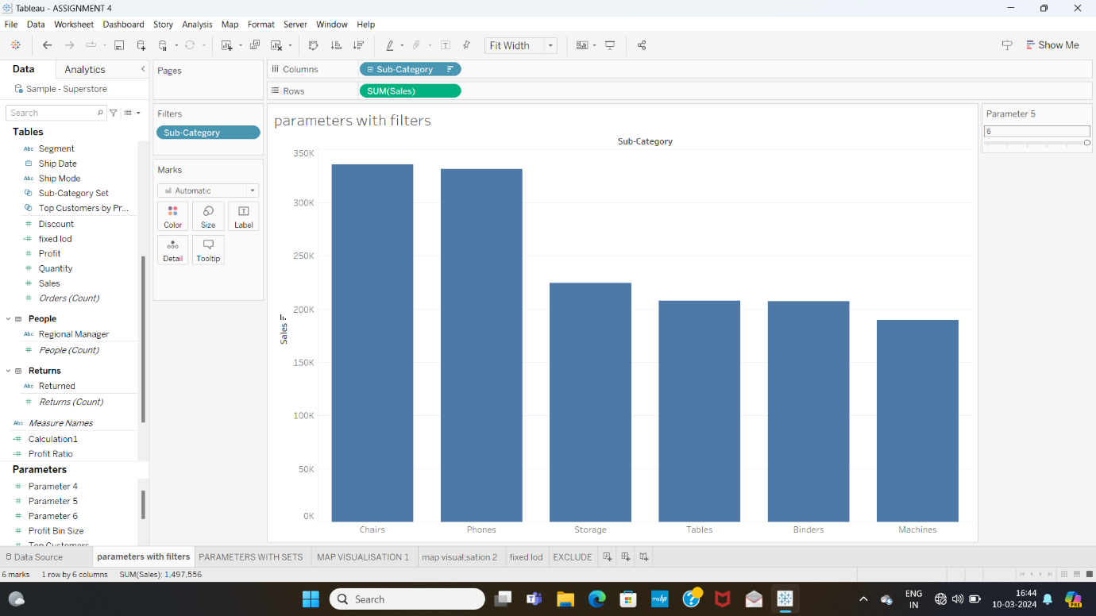

USING PARAMETER WITH A SET

